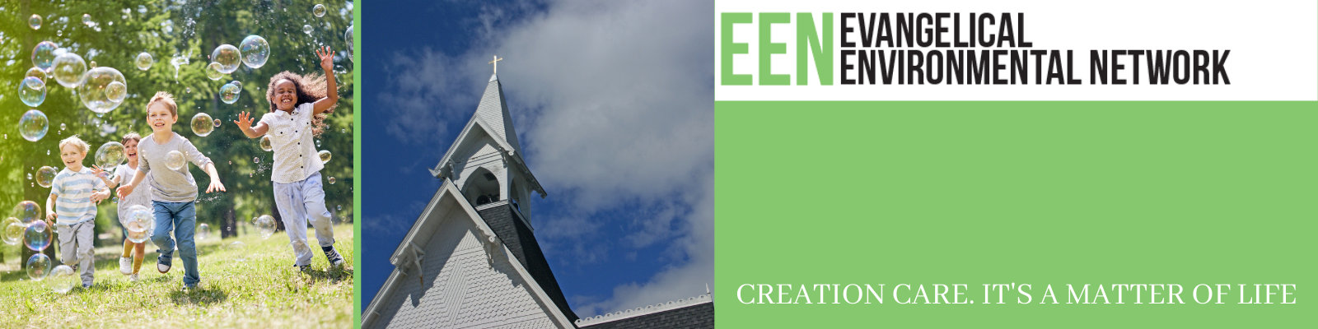
Session 5: Indigenous to Brokenness, Naturalized to Kingdom
Scripture:

Big Thought: Our allegiance is to a Kingdom that is not of this earth, yet all the Earth and all of Creation belongs to our King. We must find a way to live in the tension of being indigenous to the “not yet” of a broken world, and in our baptism becoming naturalized to the “already” of the Kingdom of God that is in-breaking in our worship, our acts of mercy and justice, our reconciled relationships and care for creation.

See It

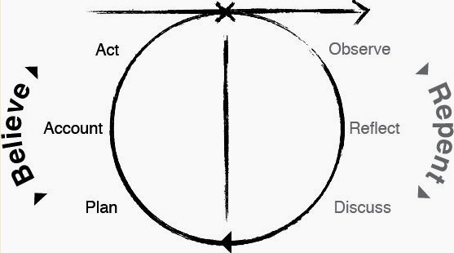

Be It
- The author defines “Indigenous” and “Naturalized” in the chapter Becoming Indigenous to Place. How are we indigenous to the fallen creation of this age and naturalized to the Kingdom of God that is to come? What does our naturalization to the Kingdom of God mean for how we live here and now?
- The author observes in The Sound of Silverbells, “The land is the real teacher...our job is to lead [others] into the presence and ready them to hear.” How does God use creation to teach us? How can we lead others into the presence and make them ready to hear?
- A key observation from Sitting In A Circle is that, “The circle of ecological compassion we feel is enlarged by direct experience of the living world, and shrunken by its lack.” How does the ‘living word’ call us to directly experience the living world? What is a consequence of us shrinking back?
- The Burning Cascade Head reveals that “Ceremony focuses attention so that attention becomes intention.” What ceremonies does God give us to focus our attention? How can we be intentional about creation through use of those ceremonies?
- We find in The Belly Button of the World that, “Balanced reciprocity has enabled life to flourish under the most stressful of conditions.” How has faith in a crucified Messiah managed to flourish under the most stressful conditions? What does balanced reciprocity look like in the Kingdom of God?
- The Wisdom of Old-Growth Children is that, “To Plant trees is an act of faith.” What acts of faith can we engage in right now by planting “trees” that will grow well beyond our ability to enjoy the results?

